V V S SANJEEV
1NT19IS183
SECTION C (BATCH 2 )

EXPERIMENT 3
MAP REDUCE
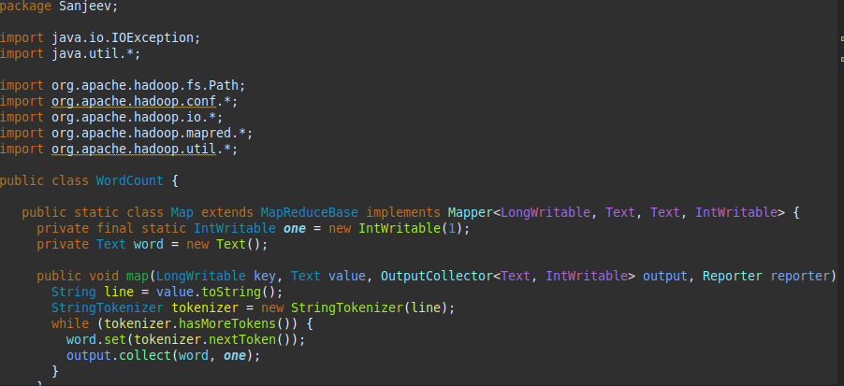

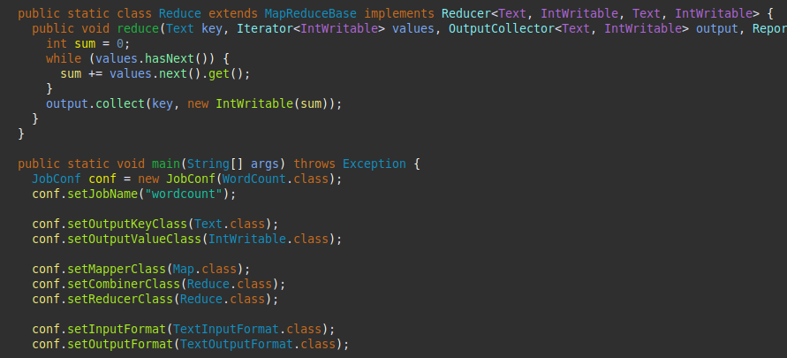

cd $HADOOP_HOME
cd sbin
jps
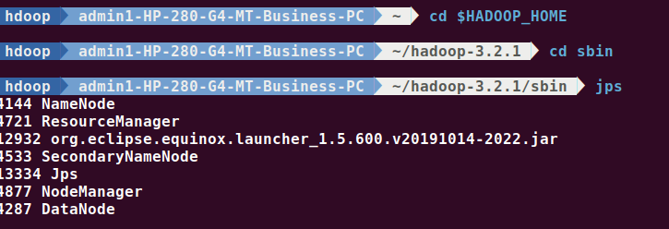

start-all.sh
hdfs dfs -mkdir -p ~ /input
hdfs dfs -appendToFile - ~/input/test.txt
this is you this is me this is all we need

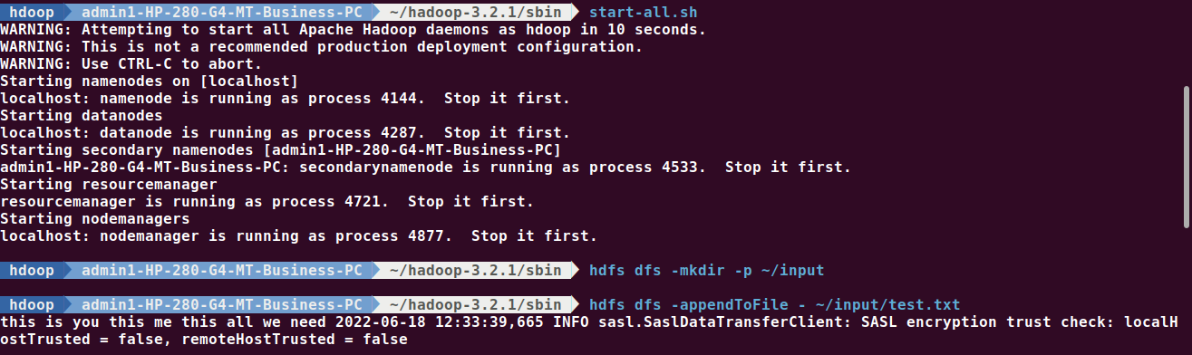

hadoop jar /home/hadoop/Desktop/sanjeev.jar ~/input ~/out

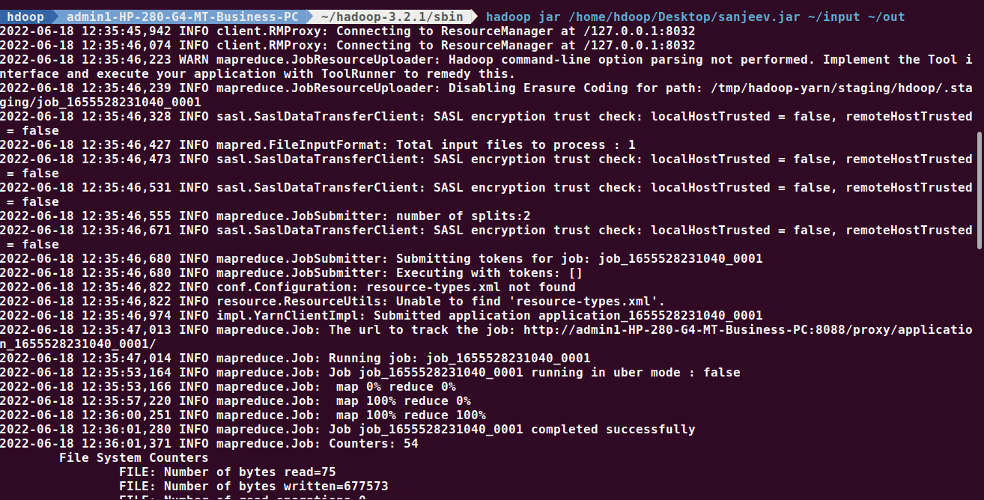

hdfs dfs -cat ~/out/part*

